1. Dags:
In Airflow, a directed acyclic graph (DAG) is a data pipeline defined in Python code
The mathematical properties of DAGs make them useful for building data pipelines:
- Directed: If multiple tasks exist, then each task must have at least one defined upstream or downstream task.
- Acyclic: Tasks cannot have a dependency to themselves. This avoids infinite loops.
- Graph: All tasks can be visualized in a graph structure, with relationships between tasks defined by nodes and vertices.

dag = DAG('impressico', description='Hello World DAG',
schedule_interval='0 12 * * *',

start_date=datetime(2017, 3, 20), catchup=False)
Task1:
task1 = PythonOperator( task_id='data_collect', python_callable=Data_collector, dag=dag )

Task2:

task2=PythonOperator(task_id ='partition',python_callable=Datapartition.read_parquet_file,dag=dag)

Task3:

task3=PythonOperator(task_id ='add_location',python_callable=FetchLocation.read_partition_data,dag=dag)

Task4:

task4=PythonOperator(task_id='timeseries', python_callable=Timeseries.add_duration,dag=dag)

task5:

task5=PythonOperator(task_id='report',python_callable=report.read_location_data,dag=dag)

task6:

task6=PythonOperator(task_id='config',python_callable=Connector.config,dag=dag)

1. Extract the data for api on a table file:

1. Extract the data from an api and store it.

We created a .py file and name it ‘collecting_data_from_source’. Create a class collecting_data and in it we will define a function data_collector by using airflow with docker that function we will fetch the data from an api and store it in a parquert file and name it with ‘parquet_data’.
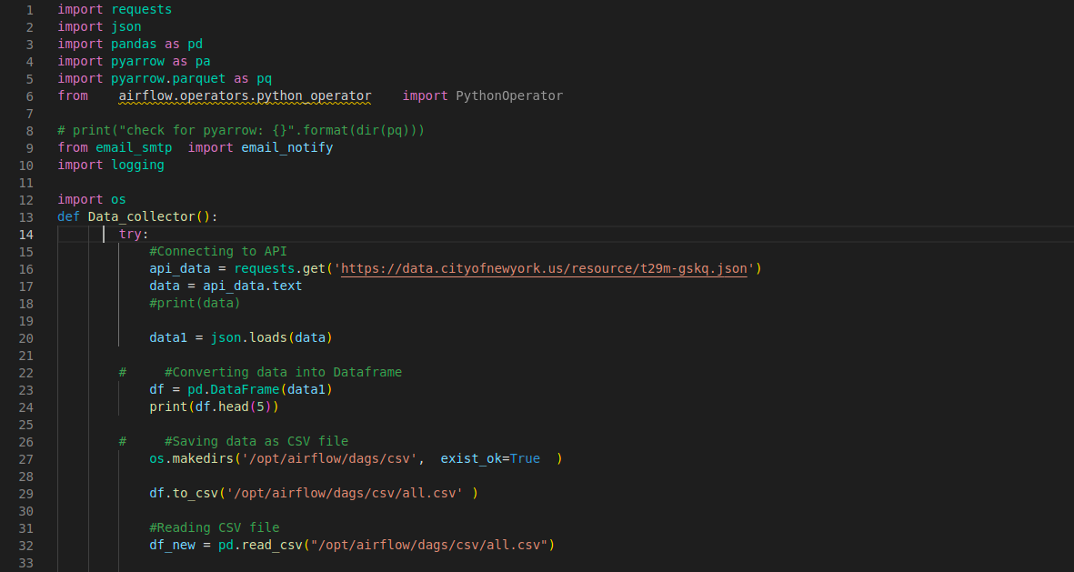
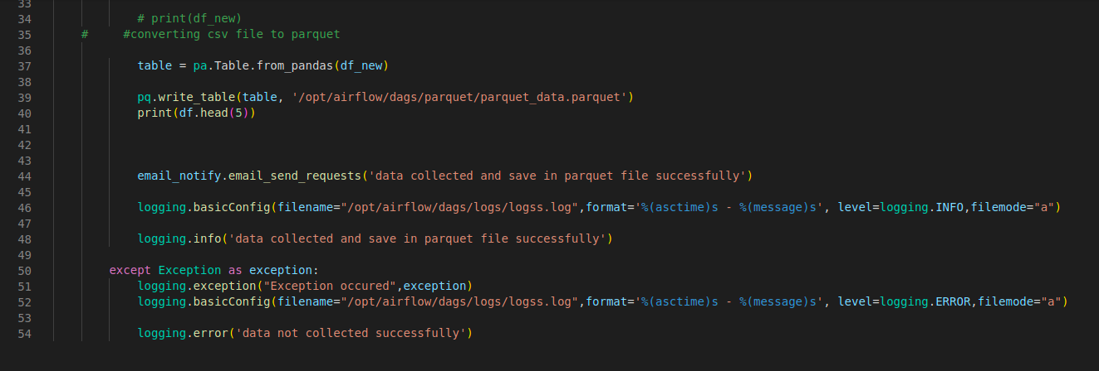

2. Transform the extracted data:

2.1 Partition the extracted data.

Now we will make a partitioning_parquet.py file and inside it created a function read_partition_data that will partitioned the collected data into four parquet file using airflow with docker and store it in a folder i.e partition_data.

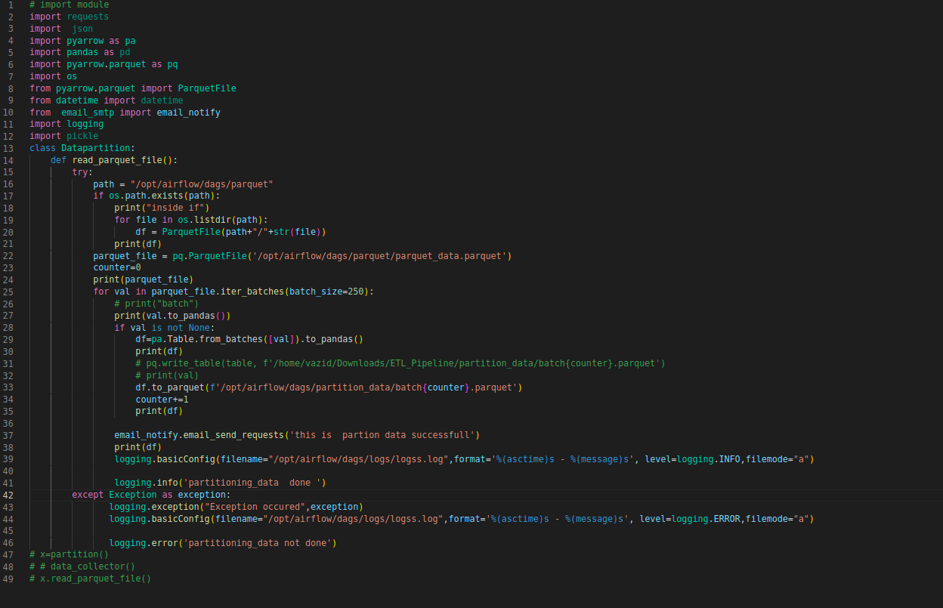

2.2 Add location coulmn in partitioned parquet file.

Now we will create a add_location.py file and make a class add_locations in which we declare a function addlocations which we will add a coulmn location in all four partitioned file and convert the parquet file in csv file and save it in a folder name location.

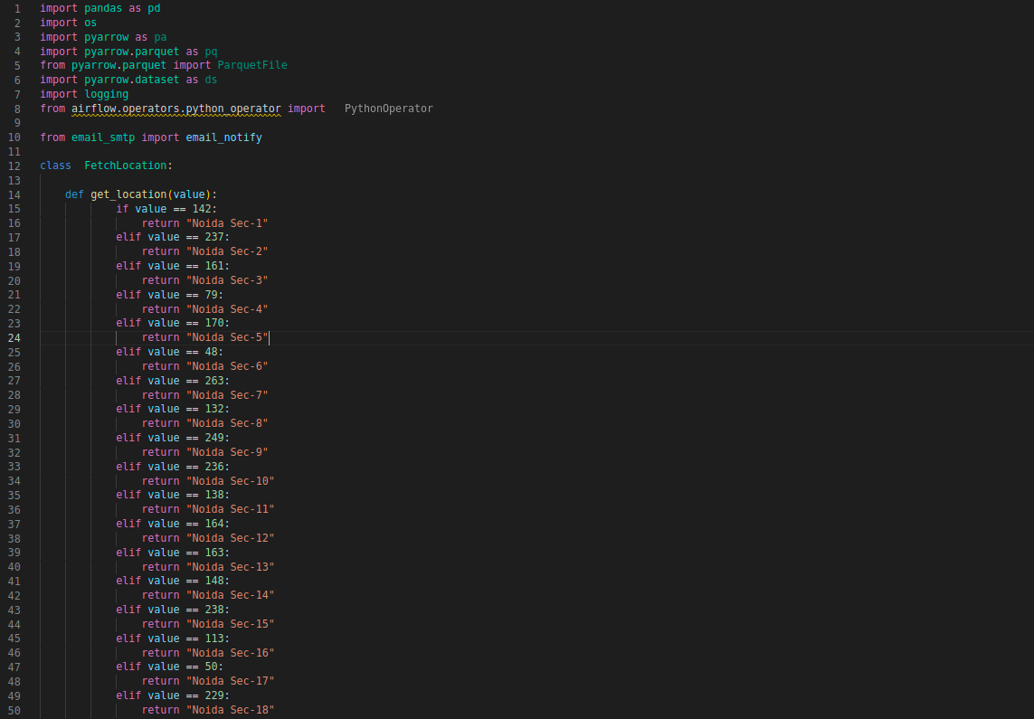

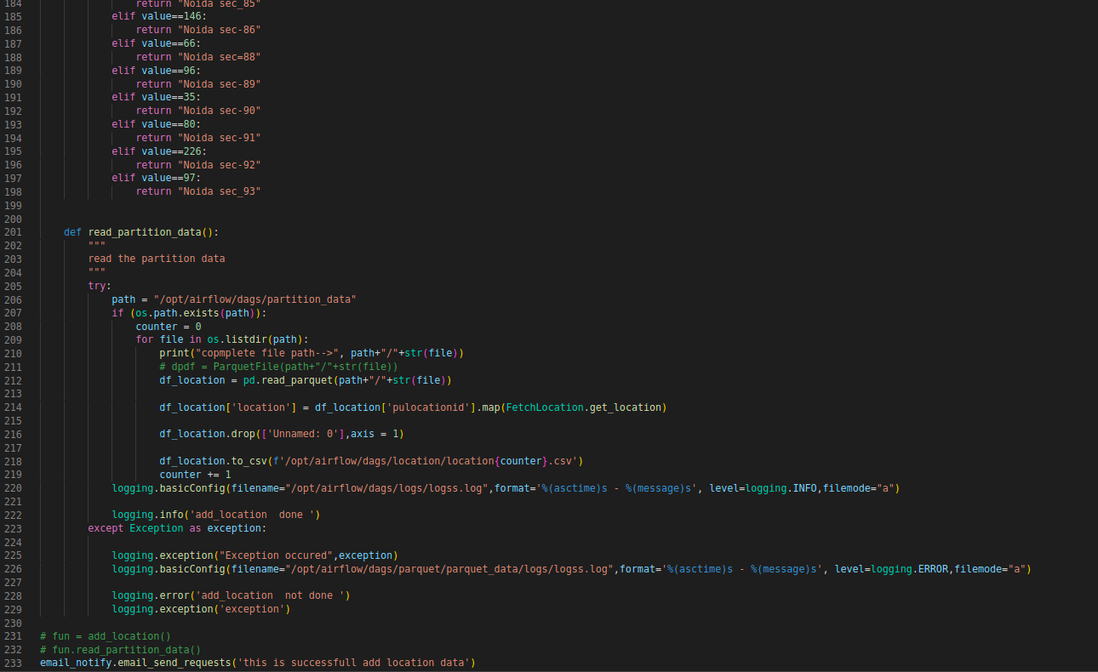

2.3 Add duration coulmn in partitioned parquet file.

Now we will create a duration.py file and make a class add_durations in which we declare a function adddurations which will add a coulmn ‘Duration’ in all four partitioned file and convert the parquet file in csv file and save it in a folder name duration.

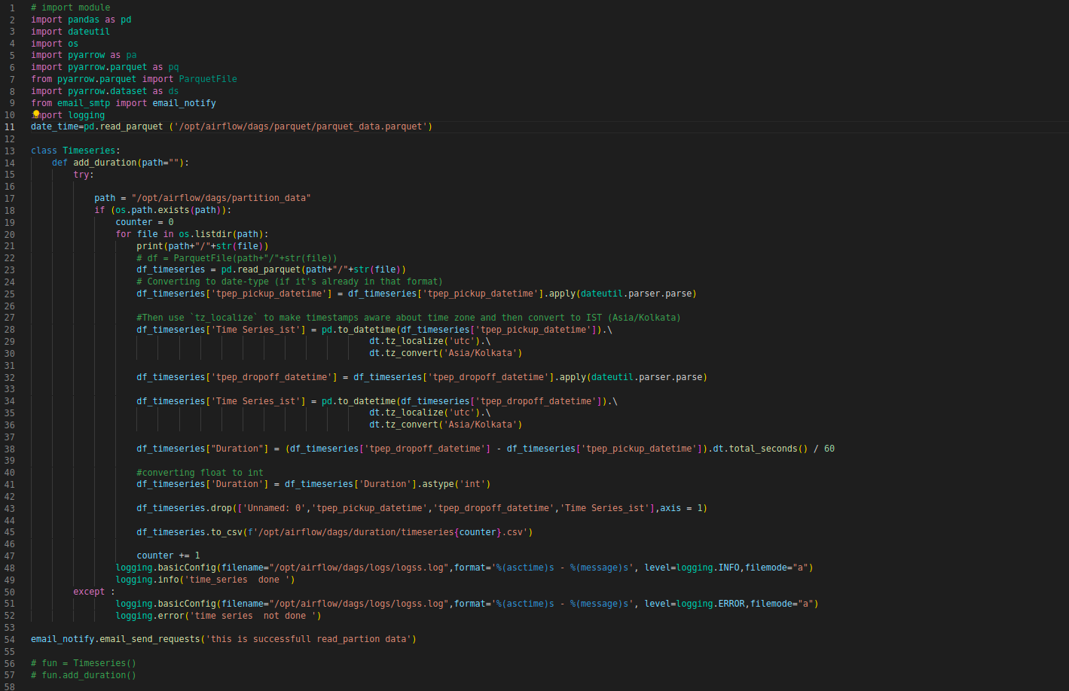

2.4 Make a report on the transform data.

Now we will make the report on the transform data like then most and least pickup or drop locations and ten maximum and minimum durations . Create a report.py file. In which we will we make a class report and inside this class we will declare some functions like maxlocations, minlocations, maxdurations and mindurations and save these in a folder report in csv format.

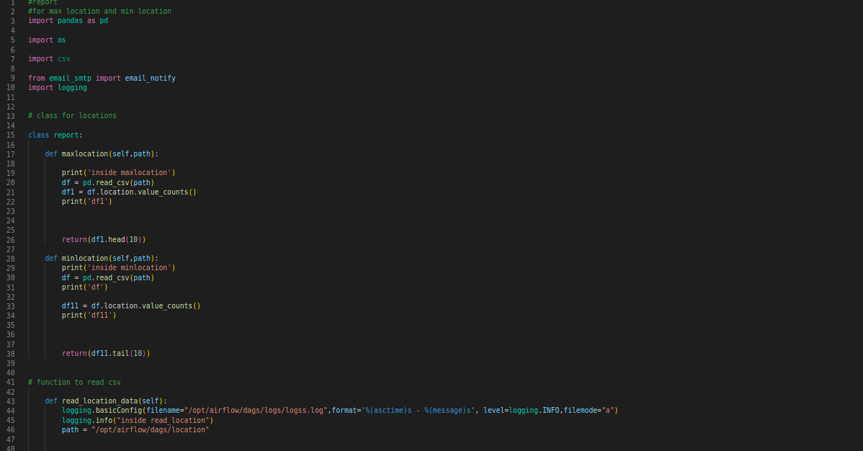
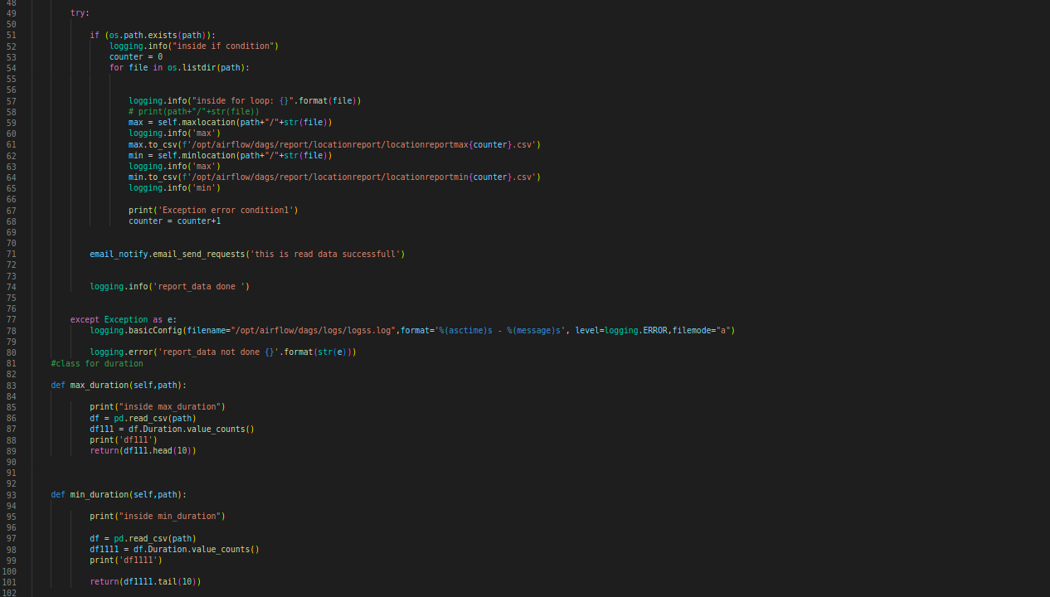

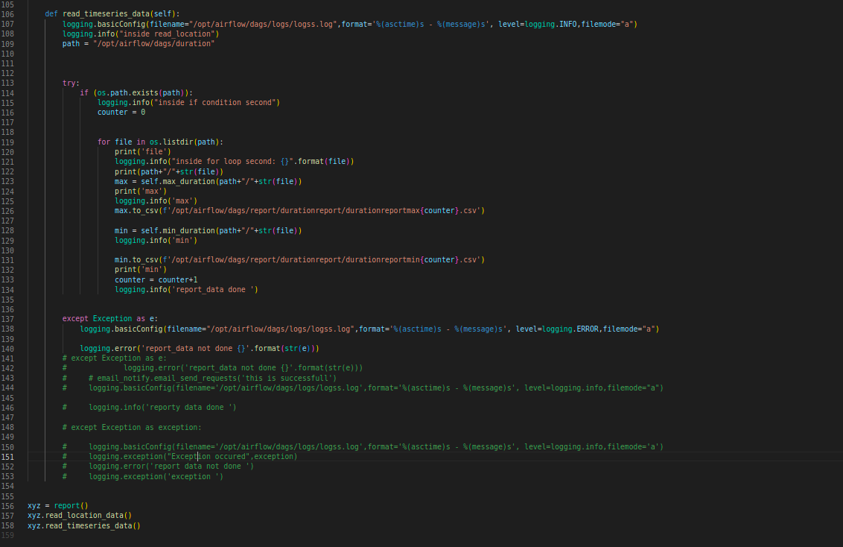

3. Load the data in database:

3.1 Make the db.ini file

We will make the db.ini file which helps in managing the multiple databases.

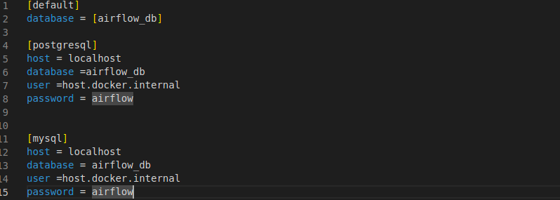

3.2 Configure the multiple database.

Make a config.py file in which define a function config which will config the multiple databases so we can access any of the databases from db.ini file .

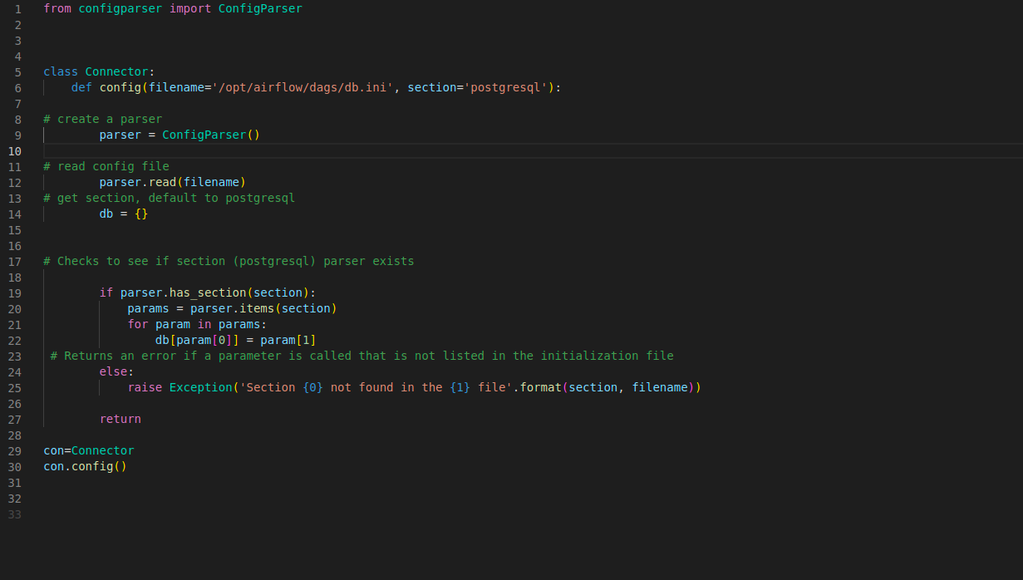

3.3 Make connection to the database.

Make a connect.py file and define a con function inside it to make the connection to the databases.

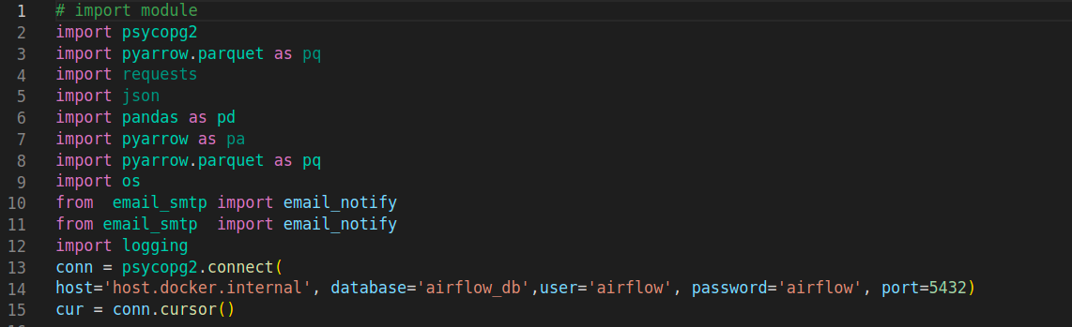
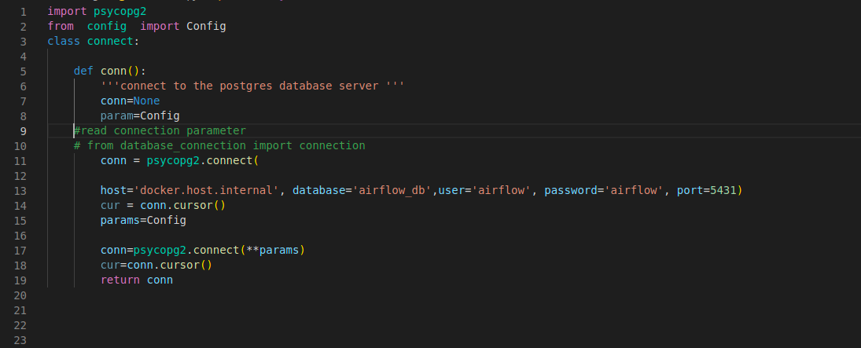

3.4 Create Table to store the data.

Now make a create_table.py file. Create a class create_tables and define a function i.e table creator which will create two tables and i.e locationreport and durationreport which will store the data of loaction report and duration report.
3.5 Insert the data into the tables.

We will make a insert_data.py file and create a class insert_data and inside it. We will define two functions in which one will insert the data of locations report and another will insert the data of duration report.

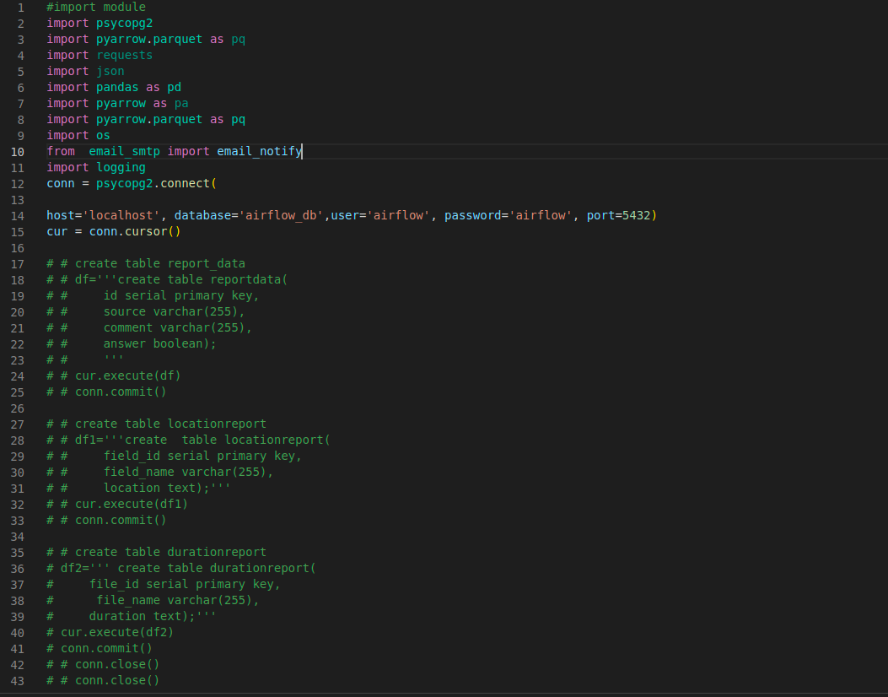

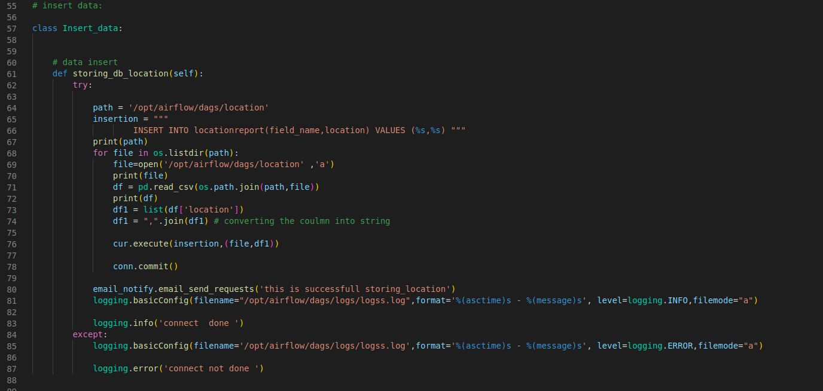
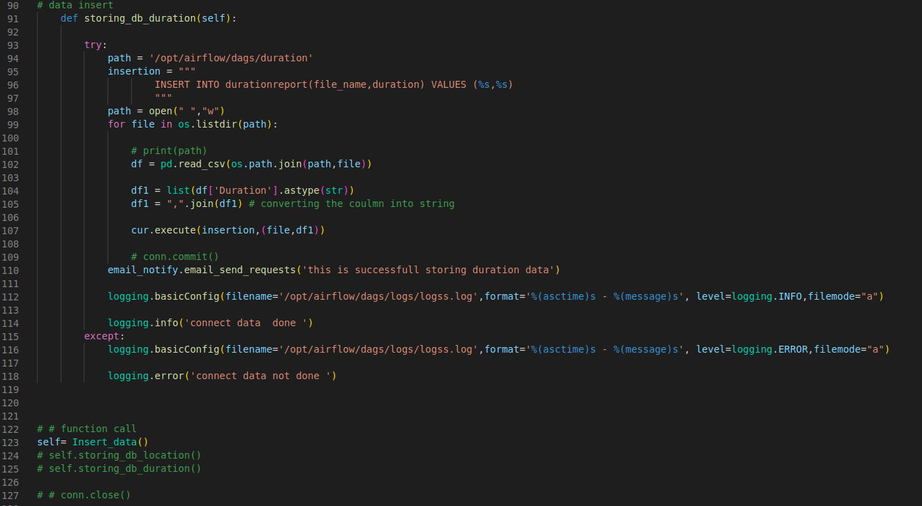

4. Attach E-mail notification.

we will create a send_email.py file and use smtp library .create a class email_notification which access the email from which we want to send the email to another person.we will import this class in all the .py file so that we can get the email for every step when it gets completed or fail.
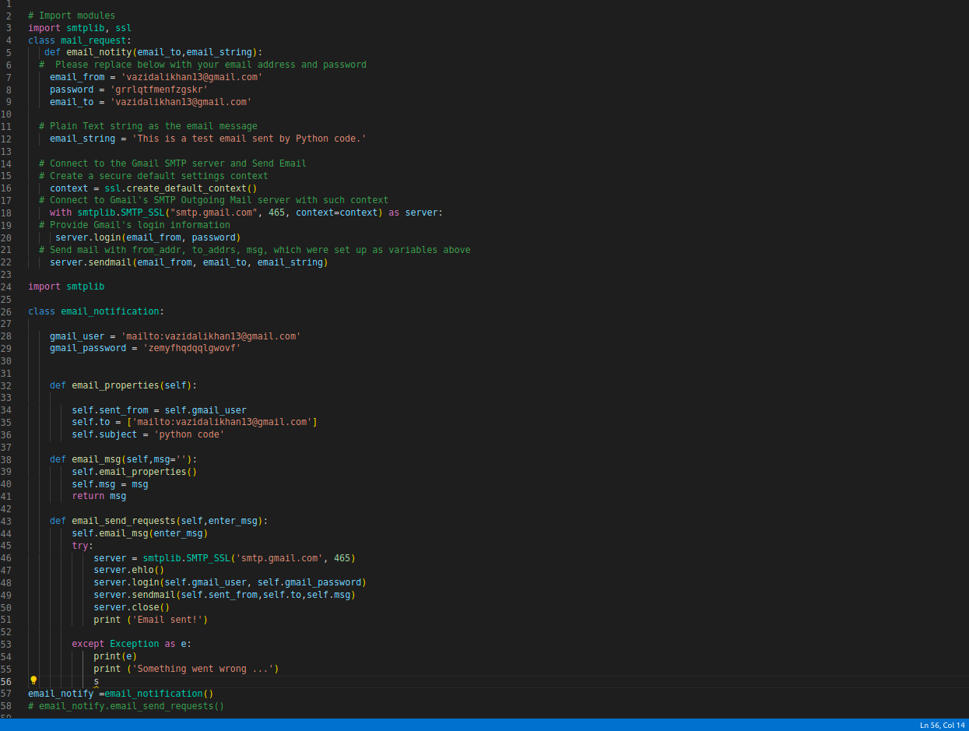

5. Add logging

Now we will add the logging in all the .py files so that by seeing the logs we can determine that process is completed or not and if not then in which step we are getting the error.

6. Dags:
When setting single direction relationships to many operators, we could concat them with bitshift composition.
Task1>>task2>>task3>>task4>>task5>>task6>>task7>>task8>>task9
then we can make a composition chain

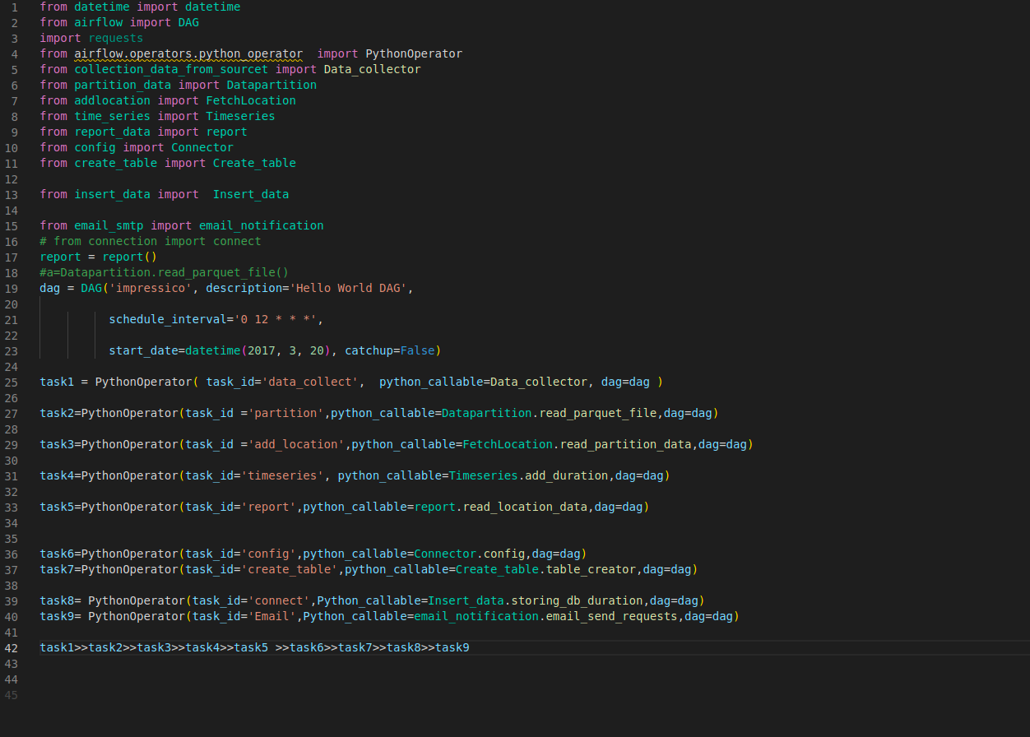

7:Url:
localhost:http://localhost:8080/home
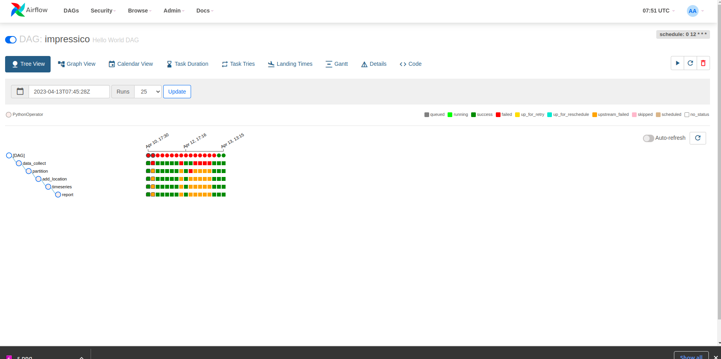

Graph: Visualization of a DAG's dependencies and their current status for a specific run.

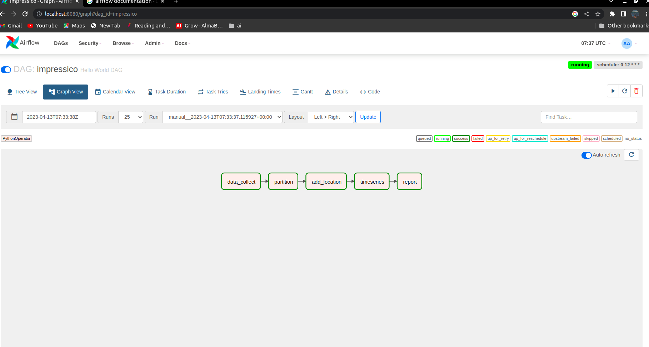

Gantt: Duration and overlap of a DAG.

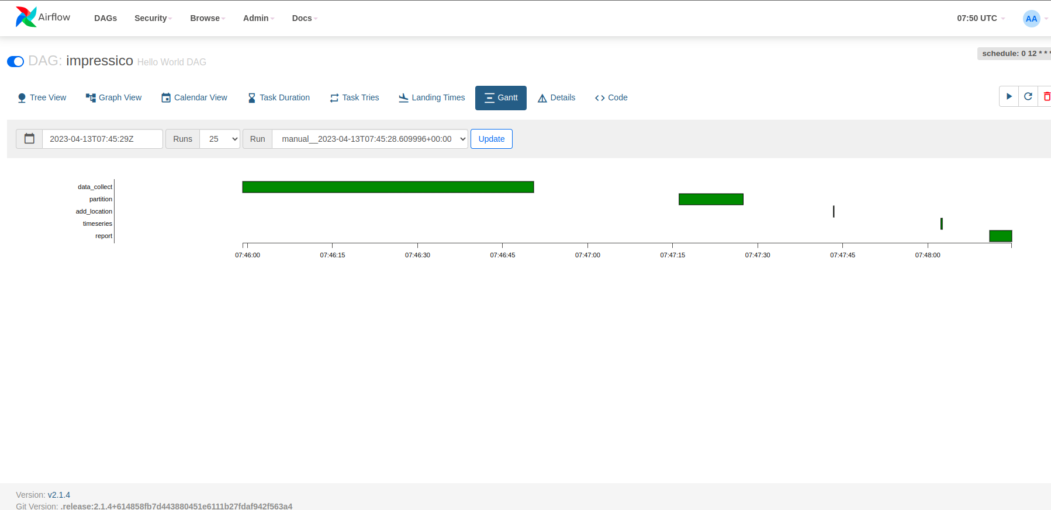
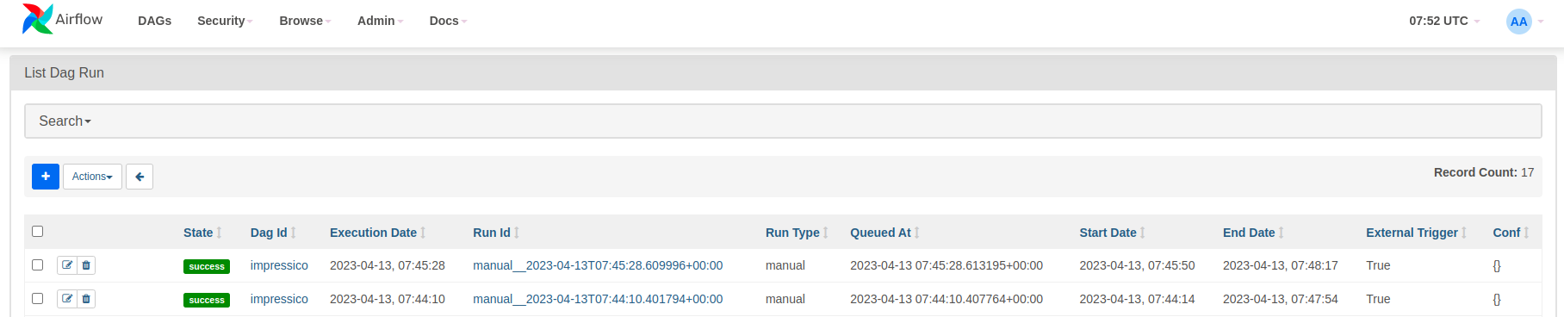
DAGs: Overview of all DAGs in your environment.

